Part 1

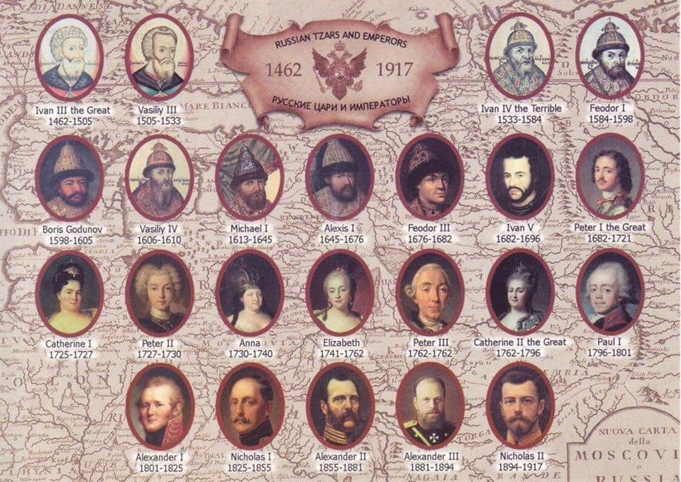

Part 1. Russia of the Tsars.
You have a choice about how you do this – any is fine.
- Print out the booklet and write in the gaps
- Download a copy and type in the gaps
- Record your answers on paper (use the same headings in your work as the page/section you are working from.)

Whichever you choose, just keep your work safe!

Extra challenge questions are optional.

TASK: For each category, identify why this would make Russia difficult to rule effectively:
The Background

Russian Geography
- 8 million sq miles: 2 x size Europe and 1/6th world surface
- Mainly rural – 11:1 village to town ratio
- Natural resources: timber, coal, oil, gold, precious minerals/metals
- Most of Russia inhospitable
- North and East had many barren lands
- Beyond the Ural Mountains, Russia was a wild place with frontier settlements.
- Transport and communication across the empire poor and difficult
- ¾ population lived within European Russia (west of Urals) – this is on less than ¼ of the
total land mass!

Nationalities
- 130 million population - Less than ½ population of the empire were Russian
- Nationalities: Romanian, Polish, Finns, Jews, Georgians etc.
- Religions: Slav/Orthodox (state religion), Muslim, Catholic, Jewish
- Each had own customs, culture, language and sometimes religion
- Many resented Russian control (Tsar’s often introduced policies which discriminated
against nationalities)

Towns and cities
- St Petersburg capital
- The Tsar and his Ministers ruled the country from there. (pop. 500,000 = size of Liverpool’s,
London was 3.5 million!)
- Towns were mainly small market centres or admin centres
- Middle class and intelligentsia almost non-existent

Agriculture
- Only 25% of Russia was really good farmland.
- Most of this was in the South and West of the country, especially in the Ukraine, the
“Bread basket” of Russia.
- The rest of Russia was either desert, arctic tundra, or taiga (woods).
- 85% or 4 out of 5 Russians were peasants. They had a hard life and there was often
starvation and disease.

Peasants
- Peasants had been emancipated in 1861 – no long had to live on mirs (communes).
- Hoped by freeing them they would become either entrepreneurial private farmers or
become mobile workers who would go to work in cities.
- Did not work as hoped; entrepreneurial class did not emerge and most continued strip
method of farming on their allotted strip using wooden tools, and lived primitive lifestyles.
Still had to ask village elders for permission to leave.
- They were generally illiterate, deeply religious, superstitious and hostile to change
- If peasants protested (for example during times of famine), the Tsar would use his feared
Cossack soldiers against them.

Middle Class and Intelligentsia
- Based in towns and cities
- Almost non-existent class – had grown during reformist era of Alexander II
thanks to university and education reforms
- Generally more educated
- Doctors, lawyers, teachers

Nobility
- 10% population yet owned 75%
- Held positions in government, army, provincial governors or administration
- Not obliged to obey Tsar but generally did
- Landowners so controlled the mirs

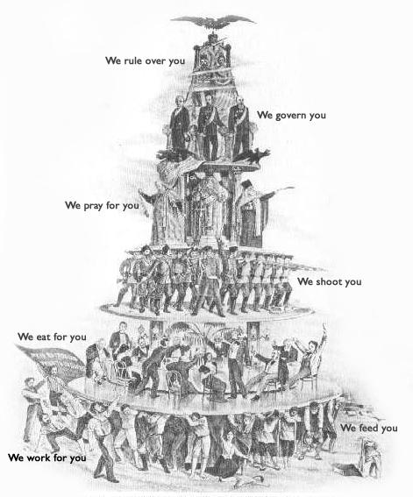

Task: Russian society:
Annotate the above source to explain what you can learn about Russian society in 1881.
Use the information below to annotate the key people and the position that they had in the social hierarchy.
Consider:
- Pyramid shape and power – who holds the most power and how many?
- What is happening to each layer as we go down.
- The flag of resistance at the bottom

Russian Tsars.

From the 16th century, the leaders of Russia and her empire used the title Tsar. Their wives had the title Tsarina. Their sons, especially the eldest, had the title Tsarevich. The term was derived from the Latin word caesar, which was intended to mean "emperor" . The Tsars ruled as autocrats, which meant they ruled alone – the opposite of democracy.

AUTOCRACY IN ACTION (TOP-DOWN SYSTEM)
Emperor and autocrat.
He alone had the power to rule.
God on earth.
Russia was his private land, the people his children.
Ruled using ukase (laws)

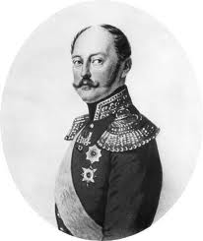
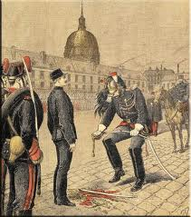
Police State
No freedom of speech, travel abroad or press. Censorship in place.
‘Third Section’ kept surveillance.
Meetings and strikes forbidden.
Anti-Tsarist behaviour = arrest or exile

Orthodox Church.
Russia deeply religious
Patriach of Moscow worked with the Tsar and Over-Procurator was appointed by the Tsar to oversee church affairs.
Bishops subject to Tsarist control over appointments, religious education and finances

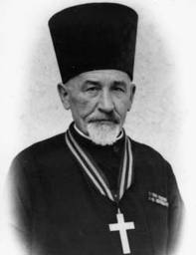
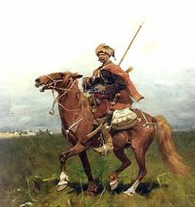
Army
1.5 million conscripted serfs – 25 years forced service.
45% gov expenditure.
Higher posts given to nobles who bought positions. Used for wars and internal uprisings.

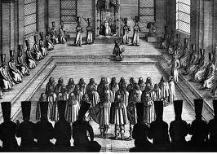
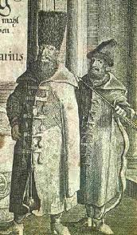
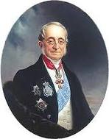
Advisors
Chosen by Tsar and could not act without Tsar’s approval.
Made up of nobles.

Bureaucracy
Paid nobles. Corrupt and incompetent. Orders passed from centre to governors of the 50 provinces. One way system - no ideas flowed up to the Tsar

Nobility
Tsar needed them for support.
Many did support as Provincial Governors. Used to control peasants on the mir. Tsar sometimes appointed committees but rarely listened to them

In Y12 you will learn about the last Tsar, Nicholas II, who ruled from 1894-1917. For background we will look at some of the rulers who preceded (ruled before) him in the 19th century.
Summary
Tsar Nicholas I = Tsar Repressor
Tsar Alexander II = Tsar Reformer/Liberator
Tsar Alexander III = Tsar Reactionist (undid a number of reforms and introduced repressive laws and changes)
Tsar Nicholas I – Tsar Repressive Autocrat.
Ruled 1825-55
- Traditional autocrat
- He used a police State/secret police to repress
- Orthodox Christian. Used religion and church as tool of control
- Continued the practice of serfdom (system in which peasants had no rights – they were tied to their lord’s land)

Tsar Alexander II – ‘Tsar Liberator’, 1855-1881; embarked on a period of reform
(reforms = changes to modernise and improve)
Reasons for introduction of reforms:
- Crimean War 1854-6 (the one where Florence Nightingale nursed British soldiers) – Russia lost.
- Growth of opposition groups – reforms were hoped to be a way to prevent them growing further
- Economic growth needed – serfdom hindered the Russian economy, industry and agriculture needed investment
- Political change: one reform led to the start of local elective governments 1864 called zemstva: they had control of education and roads but only the wealthy could vote for zemstva officials
- Social change: Emancipation of Serfs 1861, This gave peasants their freedom, however they had to pay a redemption tax for land they were given to farm and they struggled to survive. There was a reduction in censorship (could print about government policy and foreign publications allowed) and greater civil liberties., educational reform (open to all, zemstva replaced the church in charge of education, universities given freedoms)
- Economic change: foreign investment encouraged, government subsidies given to entrepreneurs developing the railways

Extra challenge question: What was Alexander II’s legacy (how did he leave Russia?)
How did he leave it weaker?
How did he leave it stronger?
Summary

Historian Lynch: Alexander III ‘s measures were so oppressive that they earned the title ‘the Reaction’.
Alexander III 1881-1904

KEY QUESTION: HOW FAR DID ALEXANDER III CHANGE RUSSIA 1881-1894?

Assassination of Alexander II 1881
- March 1st 1881 Alexander II was assassinated by populist revolutionary group the People’s Will who wanted peasants to overthrow the Tsar
- End of reformist era and start of Alexander III reactionary period. The assassination of his father convinced him that reform destabilised Russia and so a return to autocracy, control and repression was the only and best option.
The situation in 1881:
- Alexander II’s rreforms (political – zemstva 1864, education, censorship) had raised expectations across Russia.
- Disillusionment at modest outcomes of reform era = increased criticism amongst the educated classes who expected further changes and reforms, wanted to build on progress made.
- Inherited loss in Crimean and Russo-Turkish wars – some changes were required for Russia to be a Great Power.
- Alexander III convinced that reform had unsettled the masses, resulting in radicalism and assassination, and therefore Conservatism and the reaction of repression was needed to restore order and stability
Beliefs
Maintenance of autocracy – reassert the principles of autocracy’, conservative
MAIN AIMS of Alexander III:
- To reassert Tsarist control
- Curb radicalism and opposition experienced as a result of reform
- Avoid repetition of losing wars
- Secure Russia a Great Power status, strengthen and ensure future of autocracy and power of the church

Rejection of constitutional monarchy ideas
Repression and counter-reform to turn back the clock as he believed western ideas had caused chaos and urban discontent
Devoutly religious – educated by Procurator of Holy Synod – the Tsar’s Minister with responsibility for the Orthodox Christian Church

Task: Key reforms put into place by Alexander III and actions during this rule:

Area | Measure | Which of his aims did this meet?
Political | - Strong centralised control put back into place with a loyal, religious person in the position of Chief Minister. Pobedonostsev, a man who believed that the basis of political and social stability lay in support of autocracy, the Russian Orthodox Church and Russian nationalism.  - Issued a political Manifesto in 1881 (created by Pobedonostsev) declaring that absolute political power resides with the Tsar.  - Granted the nobility more powers to override zemstvo (local parliament) decisions and elections as well as overturn judicial decisions  - Zemstva electoral reform - 1890 election arrangements changed to reduce the peasants’ vote and give the nobility an advantage.  - Removal of liberal ministers who may push for, introduce or encourage western or liberal ideas. | (each area/policy may meet more than one aim)
Economic | - Finance Minister reduced the amount of tax paid by peasants.  - Creation of a Peasant Land Bank to provide financial support to the peasants, which would allow them to increase the size of their farms
Education | - Reintroduction of central control of the universities - Strict government control and supervision of universities and high fees to prevent lower class attendance and instead ensure nobility have access.  - No women or uprisings allowed at universities  - Re-introduction of church control of education to prevent radicalisation of masses and encourage the loyalty of the peasants by using the church to reinforce the importance of supporting the Tsar (paternalistic/chosen by God). No peasants/workers children to go to secondary school
Censorship and control | - Censorship, control and restriction of the freedom of the press in order to prevent the spread of western or radical ideas. This involved banning 14 major newspapers, censoring foreign books and use of the Okhrana (secret police) and the arrest of those who don’t conform.
Radical groups | - Attempt to eradicate opposition groups and radical ideas – e.g. People’s Will - through use of the Okhrana and courts.
Nationalities | - Extension of the policy of Russification (to impose Russian culture on all parts of the empire) to prevent the radicalisation and uprising of nationalities who wanted more independence. Made it law that the Russian language was used throughout Russia including documents, books and schools  - Encourage, approve or organise pogroms (attacks: rape, beatings, murder) against Russia’s Jews living in the ‘Jewish Pale’. Use of them as a scapegoat for issues within Russia.

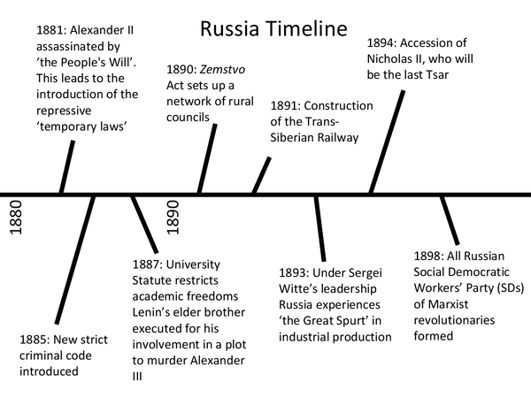
What happened to the economy under Alexander II and Alexander III?

Progress under Alexander II
- Emancipated the serfs 1861
- Maintained social stability
- Pioneered railway expansion – started rail growth. Limited.
- Some new factories
- Set up modern banking system
Impact?
(+) Major cities had shown massive growth e.g. Kiev, Moscow
(-) Russo-Turkish War showed how perilous financial stability was
(-) Reutern resigned when the rouble declined in 1878
(-) social disruption soon broke out e.g. Urban strikes

Task: Read each reason for economic reform below and then rank them order 1- 10.
1 will be the most important reason for reform and industrialisation:

WHY DID ALEXANDER II AND HIS MINISTERS REFORM THE ECONOMY AND INDUSTRIALISE?

- Crimean War (1851-6) and Russo-Turkish War (1877-78) had illustrated the country’s industrial backwardness and led to humiliation – loss of war against smaller countries (Turkey, Britain, France)

- Agriculture (farming) was backward: former serfs were burdened with redemption payments and landowners with debt making agricultural investment limited/by 1880 only ½ of agricultural land was producing surpluses causing a crisis of supply resulting in famines.

- Western European Competition: Britain and Germany were speeding ahead and other European rivals were experiencing industrial revolutions. Evidence: Productivity between 1840-1990 rose 50 percent in Belgium, 190 percent in Germany, and an average of 75 percent from all of Europe whilst Russia’s grew just 30%; western Europe had modernised their agricultural practices making it harder for Russia to sell grain in global markets.

- Need to encourage an industrial revolution: Industrial revolutions were important because they transformed military capacities (new technology, weapons) and increased productivity. Russia’s productivity was still incredibly low.

- Develop an effective infrastructure: to transport goods and exports, machinery and to encourage a mobile industrial workforce: 8 million square miles largely unconnected, communication of new laws was slow, emancipated serfs had not made the move to the cities with St Petersburg population still just 1 million 1890, no effective links between capital and Eastern empire

- Protection: To prevent Russian security and its military power and empire being threatened, it too would have to change and modernise to defend its borders. Also, more factories would be needed to produce armaments to improve their military strength

- Curb social unrest and revolutionary activity – to help avoid famines, social inequalities, and discontent which could be aimed at the tsarist regime, it was necessary to modernise and try to improve the conditions of those who could bring the system down

- Social engineering: Create an entrepreneurial class and productive workforce – to invest in new factories, industry and the infrastructure and ensure maximum productivity

Extra Challenge Task: Justify 2-3 of your choices

Progress under Alexander III

We must go hungry, but export!

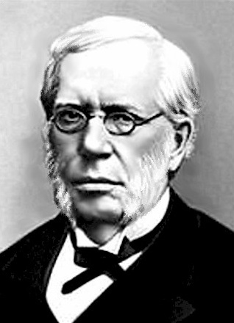
Impact of Vyshnegradsky 1887-1892 (Minister of Finance)
Aim was to improve Russia’s finances and build up gold reserves
- Increased indirect taxes
- Aim to swell grain exports
- Reduced imports by increasing tariffs - 33% as part of the Tariff Act of 1891.
- This was to protect Russian iron, industrial machinery and raw cotton from competition
- Loans from abroad to kickstart growth, e.g. France 1888

Impact
(+) Economy did grow. This had a SUPERFICIAL effect and with the aid of French loans the Russian economy made a surplus in 1892.
(+) 1881-1891 grain exports rose by 18%
(-) However this put pressure on the peasantry – bore brunt of indirect taxation which limited their purchasing power. Price of goods rose because of import tax so could afford even less. Peasant grain was requisitioned (taken forcibly) to sell abroad by government – peasants often didn’t have reserve stores and went hungry = Famine of 1891-2. Affected 17/39 Russian provinces and 350,000 died (starvation, disease) including many able bodied workers leaving no breadwinner in many families.
(-) Led to growth of opposition - This came in tandem with government failure to organise effective relief and volunteer groups to help stricken peasants. Due to this poor response, the call came for even more liberal reform of government.
Task: Aims for the economy included increasing food supply and reducing unrest and opposition. Why didn’t this work under Alexander III?

Witte - a Minister of the government put in charge of railways and areas of the economy by Alexander III. What did he do to try and modernise Russia?
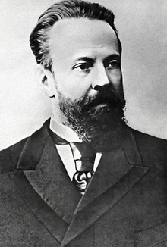
Methods:
- State Control - Russia needed to be directed ‘from above’ as there
Save Russia by rapid and forceful industrialisation.’
was no entrepreneurial class
- Use ‘state capitalism’ like Vyshnegradsky
- Protective tariffs (tax on imports)
- Heavy taxation (peasants)
- Forced exports to generate capital
- Raise domestic loans from national revenue to finance enterprises such as rail
- Loans from abroad. To encourage these loans and foreign confidence Witte needed to stabilise the currency and raise interest rates
= introduced the rouble as currency (backed by value of gold)
- Foreign investment: foreign capitalists (stabilised rouble) want to invest in coal, iron and steel
- Use foreign experts and workers e.g. Engineers and workers from France and Britain to oversee industrial developments
- Develop infrastructure (rail/communication) – to transport goods, machinery and mobile industrial workers (turn those former serfs into industrial workers)
- Encourage emigration to Siberia 1896 – get peasants/growing population to move there and exploit resources in Siberia to produce grain surpluses to fund industrialisation/prevent overpopulation in some areas

Task: Explain 3 ways in which Witte did help to modernise Russia

Heavy Industry Growth
HOT SPOTS
Engineering:
- St Petersburg
- Moscow
- Poland
- Riga
Metallurgy:
- Urals
- Poland
- Caspian Sea/Baku 1871
- Caucusus
Coal
- Baku coalfields
- Poland
- Donbas
1880s and 1890s

- Witte saw the need to concentrate on heavy goods production. Production in key areas by developing large factory units of over 1000 workers would be the way to achieve this.

Successes:
- Trans-Siberian Railway was built (5,772 miles!)
- Increase in exports and foreign trade
- Imports and exports grew in quantity and value
- Trading with other nations: Germany, UK, China, USA
- Continued foreign investment – Nobel, Rothschild in Baku

Failures:
- Bulk of export trade was still grain rather than industrial goods and this
increase still fell short of Witte’s predictions
LINK BETWEEN RAIL AND HEAVY INDUSTRY
- Growth of rail led to opening up of Russian interior so new areas of natural resources
- Linked major industrial areas and agricultural areas together and with ports and markets
- Stimulated development of coal and iron with new industrial areas along the length of rail track
- Trans-Siberian rail huge industrial stimulus
- Psychological boost – encouraged foreign investors to finance Russia industry

- Trans-Siberian rail development was huge drain on finances
- Under Witte, state budget doubled eating into profits of economic growth
- Dependence on foreign loans which had to be paid back with interest
- Focus on heavy industry led to a neglect of domestic and light industry
- Neglect of agricultural modernisation – reinforced by assumption that
peasants could just simply be forced into producing more grain

Task: ‘Heavy industry policies were mostly successful’. How far do you agree?

SOCIAL CHANGES CAUSED BY INDUSTRIALISATION
Task: Summarise the main problems facing each social class

Middle Class

Urban Working Class

Rural peasants

Middle Class:
- More got jobs in middle management (small workshop owners, traders, merchants)
- More ‘non-nobles’ becoming factory owners
- Greater demand for professionals: teachers, lawyers, bankers, doctors
- Still small section of society (½ million) in between larger division of peasants and nobility
- Not given a voice in central government
- Middle Class gained places in zemstva where they could influence local decision making
- Other western countries had moderate liberal minded middle class as backbone of establishment –
not the case in Russia
- This led to a growth of revolutionary leaders from a middle class background
Urban Working Class
- When industrialisation started, it was common for some workers to move to towns temporarily,
keeping land and then returning to it
- 6 million workers by 1914 – ¾ were peasants by birth
- Increasingly, migrants to towns found that the meagre allocation of land left at home produced a poor
subsidy and sold up. They moved from town to town following work.
- Some found regular work, settled and their children became urban workers by birth

Facilities:
- Barrack like buildings owned by factory owners
- Factory owners used it as method of maintaining and controlling workers like prison ‘inmates’
- Dangerously overcrowded – St Petersburg survey 1904: 16 per apartment
- Inadequate sanitation and basic provisions – canteens, communal baths, planks for beds
- St Petersburg: 40% houses had no running water/sewage system
- Cholera outbreak 1908-9 with 30,000 dead
- Demand for work meant rent remained high (1/2 workers wage at times) – Saratov 1900 food and rent
was ¾ workers wage with clothes/laundry/baths accounting for rest
- Some slept rough or alongside their machines

Wages:
- Varied dependent on skilled or unskilled category, overtime and fines
- Women lowest paid (less than ½ industrial wage)
- During times of industrial revival wages did not keep up with inflation
Working Conditions:
- 1908-9 worst during industrial depression
- Workers protests remained in minor due to law against strikes until 1905.
Although: 1886-1894 33 strikes per year, 1895-1904 176 strikes per year
- Brutish treatment by owners – swapped one master in the countryside for another in the cities.
Many had experienced harsh conditions as peasants or were desperate for work so put up with
conditions. Non-noble factory owners did not share ‘paternalistic’ moral obligation to look after
workers

Rural peasants working in agriculture
- 80-90% of Russian population
- Population growth led to subdivision of land – size of farms fell from 35 acres to 28 by 1905
- Inefficient farming methods – kept wooden ploughs
- Outbreak of rural lawlessness: the worst since the 1860’s with arson attacks and looting
- Kulaks – capitalist wealthier class of peasant who used poorer peasants for cheap labour
- Kulaks used the peasant banks to buy out impoverished neighbours
Experience of the peasants
- Life became harsher
- Increasing numbers forced to leave their farms and migrate to cities
- Some took up government schemes to emigrate to new agricultural settlements e.g. to Siberia

Living Standards
- Living standards varied in different parts of the country
- Prosperous areas: Ukraine and Baltic
- Backwards farming methods and land owned by nobles: Russian heartland
- Highest mortality rates in Europe – average life expectancy was 27.25 years (45.25 in England)

Task: ‘The position of the peasantry largely improved, 1881-1904’. How far do you agree?

Extra challenge question. What will be the biggest problem facing the next Tsar?

